**Experiment No. 1**

**Aim:** Amber's conglomerate corporation just acquired some new companies. Each of the companiesfollows this hierarchy:

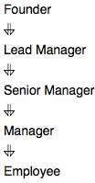

Given the table schemas below, write a query to print the company_code, founder name, total number of lead managers, total number of senior managers, total number of managers, and total number of employees. Order your output by ascending company_code.

Note:

The tables may contain duplicate records.

The company_code is string, so the sorting should not be numeric. For example, if the company_codes are C_1, C_2, and C_10, then the ascending company_codes willbe C_1, C_10, and C_2.

**Objective:** To extract the data from relations and analyze the results using sql concepts

**Sample Input**

Company Table:

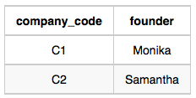

Lead_Manager Table:

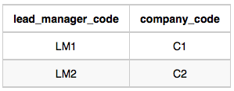

Senior_Manager Table:

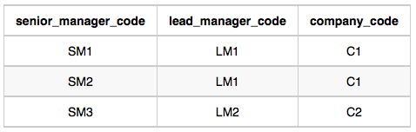

Manager Table:

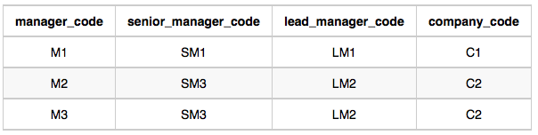

Employee Table:

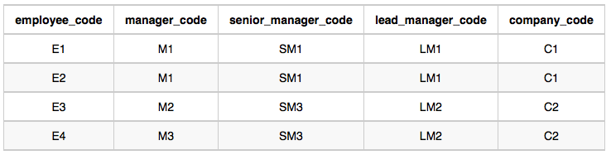

**Output**

C1 Monika 1 2 1 2  
C2 Samantha 1 1 2 2

create table company(company_code varchar(50), founder varchar (100));

insert into company values('C1','Monika');

insert into company values('C2','seema');

select*from company;

create table Lead_manager(lead_manager_code varchar(50), company_code varchar (50));

insert into Lead_manager values('LM1','C1');

insert into Lead_manager values('LM2','C2');

select*from Lead_manager;

create table senior_manager(senior_manager_code varchar (50),lead_manager_code varchar (50), company_code varchar(50));

insert into senior_manager values('SM1','LM1','C1');

insert into senior_manager values('SM2','LM1','C1');

insert into senior_manager values('SM3','LM2','C2');

select*from senior_manager;

create table manager(manager_code varchar(50), senior_manager_code varchar (50),lead_manager_code varchar(50), company_code varchar(50) );

insert into manager values('M1','SM1','LM1','C1');

insert into manager values('M2','SM3','LM2','C2');

insert into manager values('M3','SM3','LM2','C2');

select*from manager;

create table Employee( employee_code varchar (50), manager_code varchar (50), senior_manager_code varchar (50), lead_manager_code varchar (50),company_code varchar (50));

insert into Employee values( 'E1', 'M1', 'SM1', 'LM1', 'C1');

insert into Employee values( 'E2', 'M1', 'SM1', 'LM1', 'C1');

insert into Employee values( 'E1', 'M2', 'SM3', 'LM2', 'C2');

insert into Employee values( 'E2', 'M3', 'SM3', 'LM2', 'C2');

select*from Employee;

select c.company_code, c.founder, count(distinct lm.lead_manager_code), count(distinct sm.senior_manager_code), count(distinct m.manager_code), count(distinct e.employee_code) from Company c, Lead_Manager lm, Senior_Manager sm, Manager m, Employee e where c.company_code = lm.company_code and lm.lead_manager_code = sm.lead_manager_code and sm.senior_manager_code = m.senior_manager_code and m.manager_code = e.manager_code group by c.company_code, c.founder order by c.company_code

